**Nelson Rolihlahla Mandela** ([/](http://en.wikipedia.org/wiki/Help:IPA_for_English)[mænˈdɛlə](http://en.wikipedia.org/wiki/Help:IPA_for_English#Key)[/](http://en.wikipedia.org/wiki/Help:IPA_for_English);[[4]](http://en.wikipedia.org/wiki/Nelson_Mandela#cite_note-4) [Xhosa](http://en.wikipedia.org/wiki/Xhosa_language" \o "Xhosa language)pronunciation: [[xoˈliːɬaɬa manˈdeːla]](http://en.wikipedia.org/wiki/Help:IPA); 18 July 1918 – 5 December 2013) was a South African [anti-apartheid revolutionary](http://en.wikipedia.org/wiki/Internal_resistance_to_South_African_apartheid),[politician](http://en.wikipedia.org/wiki/Politician) and [philanthropist](http://en.wikipedia.org/wiki/Philanthropy) who served as [President of South Africa](http://en.wikipedia.org/wiki/President_of_South_Africa) from 1994 to 1999. He was South Africa's first black chief executive, and the first elected in a [fully representative](http://en.wikipedia.org/wiki/Universal_suffrage)democratic election. [His government](http://en.wikipedia.org/wiki/Presidency_of_Nelson_Mandela) focused on dismantling the legacy of [apartheid](http://en.wikipedia.org/wiki/Apartheid_in_South_Africa) through tackling institutionalised racism, poverty and inequality, and fostering racial reconciliation. Politically an [African nationalist](http://en.wikipedia.org/wiki/African_nationalism) and [democratic socialist](http://en.wikipedia.org/wiki/Democratic_socialism), he served as [President of the African National Congress](http://en.wikipedia.org/wiki/History_of_the_African_National_Congress) (ANC) from 1991 to 1997. Internationally, Mandela was Secretary General of the [Non-Aligned Movement](http://en.wikipedia.org/wiki/Non-Aligned_Movement) from 1998 to 1999.

A [Xhosa](http://en.wikipedia.org/wiki/Xhosa_people) born to the [Thembu](http://en.wikipedia.org/wiki/Thembu) royal family, Mandela attended the [Fort Hare University](http://en.wikipedia.org/wiki/Fort_Hare_University) and the [University of Witwatersrand](http://en.wikipedia.org/wiki/University_of_Witwatersrand), where he studied law. Living in [Johannesburg](http://en.wikipedia.org/wiki/Johannesburg), he became involved in [anti-colonial](http://en.wikipedia.org/wiki/Anti-colonialism) politics, joining the ANC and becoming a founding member of its [Youth League](http://en.wikipedia.org/wiki/African_National_Congress_Youth_League). After the [South African National Party](http://en.wikipedia.org/wiki/National_Party_(South_Africa)) came to power in 1948, he rose to prominence in the ANC's 1952 [Defiance Campaign](http://en.wikipedia.org/wiki/Defiance_Campaign), was appointed superintendent of the organisation's [Transvaal](http://en.wikipedia.org/wiki/Transvaal_Province" \o "Transvaal Province)chapter and presided over the 1955 [Congress of the People](http://en.wikipedia.org/wiki/Congress_of_the_People_(1955)). Working as a lawyer, he was repeatedly arrested for seditious activities and, with the ANC leadership, was unsuccessfully prosecuted in the [Treason Trial](http://en.wikipedia.org/wiki/Treason_Trial) from 1956 to 1961. Influenced by [Marxism](http://en.wikipedia.org/wiki/Marxism), he secretly joined the [South African Communist Party](http://en.wikipedia.org/wiki/South_African_Communist_Party) (SACP) and sat on its Central Committee. Although initially committed to non-violent protest, in association with the SACP he co-founded the militant [Umkhonto we Sizwe](http://en.wikipedia.org/wiki/Umkhonto_we_Sizwe" \o "Umkhonto we Sizwe) (MK) in 1961, leading a [sabotage](http://en.wikipedia.org/wiki/Sabotage) campaign against the apartheid government. In 1962, he was arrested, convicted of conspiracy to overthrow the state, and sentenced to life imprisonment in the [Rivonia Trial](http://en.wikipedia.org/wiki/Rivonia_Trial" \o "Rivonia Trial).

Mandela served 27 years in prison, initially on [Robben Island](http://en.wikipedia.org/wiki/Robben_Island" \o "Robben Island), and later in [Pollsmoor Prison](http://en.wikipedia.org/wiki/Pollsmoor_Prison" \o "Pollsmoor Prison) and [Victor Verster Prison](http://en.wikipedia.org/wiki/Drakenstein_Correctional_Centre). An international campaign lobbied for his release. He was released in 1990, during a time of escalating civil strife. Mandela joined negotiations with President [F. W. de Klerk](http://en.wikipedia.org/wiki/F._W._de_Klerk) to abolish apartheid and establish [multiracial elections in 1994](http://en.wikipedia.org/wiki/South_African_general_election,_1994), in which he led the ANC to victory and became South Africa's first black president. He published [his autobiography](http://en.wikipedia.org/wiki/Long_Walk_to_Freedom) in 1995. During his tenure in the [Government of National Unity](http://en.wikipedia.org/wiki/Government_of_National_Unity_(South_Africa)) he invited other political parties to join the cabinet, and promulgated a [new constitution](http://en.wikipedia.org/wiki/Constitution_of_South_Africa). He also created the [Truth and Reconciliation Commission](http://en.wikipedia.org/wiki/Truth_and_Reconciliation_Commission_(South_Africa)) to investigate past [human rights](http://en.wikipedia.org/wiki/Human_rights) abuses. While continuing the former government's [liberal economic policy](http://en.wikipedia.org/wiki/Economic_liberalism), his administration also introduced measures to encourage [land reform](http://en.wikipedia.org/wiki/Land_reform), combat poverty, and expand healthcare services. Internationally, he acted as mediator between Libya and the United Kingdom in the [Pan Am Flight 103 bombing trial](http://en.wikipedia.org/wiki/Pan_Am_Flight_103_bombing_trial), and oversaw [military intervention in Lesotho](http://en.wikipedia.org/wiki/Southern_African_Development_Community_intervention_in_Lesotho). He declined to run for a second term, and was succeeded by his deputy, [Thabo Mbeki](http://en.wikipedia.org/wiki/Thabo_Mbeki). Mandela became an elder statesman, focusing on charitable work in combating poverty and [HIV/AIDS](http://en.wikipedia.org/wiki/HIV/AIDS) through the Nelson Mandela Foundation.

Mandela was a controversial figure for much of his life. Denounced as a communist [terrorist](http://en.wikipedia.org/wiki/Terrorist) by critics,[[5]](http://en.wikipedia.org/wiki/Nelson_Mandela#cite_note-5)[[6]](http://en.wikipedia.org/wiki/Nelson_Mandela#cite_note-6) he nevertheless gained international acclaim for his activism, having received [more than 250 honours](http://en.wikipedia.org/wiki/List_of_Nelson_Mandela_awards_and_honours), including the 1993[Nobel Peace Prize](http://en.wikipedia.org/wiki/Nobel_Peace_Prize), the US [Presidential Medal of Freedom](http://en.wikipedia.org/wiki/Presidential_Medal_of_Freedom), and the Soviet [Order of Lenin](http://en.wikipedia.org/wiki/Order_of_Lenin). He is held in deep respect within South Africa, where he is often referred to by his [Xhosa clan name](http://en.wikipedia.org/wiki/Xhosa_clan_name), **Madiba**, or as **Tata** ("Father"); he is often described as "the father of the nation".

Nelson Mandela became the first black president of South Africa in 1994, serving until 1999. A symbol of global peacemaking, he won the Nobel Peace Prize in 1993.

**IN THESE GROUPS**

* [FAMOUS GOVERNMENT](http://www.biography.com/people/groups/government)
* [FAMOUS CANCERIANS](http://www.biography.com/people/groups/cancer)
* [FAMOUS PEOPLE BORN IN MVESO, TRANSKEI](http://www.biography.com/people/groups/birth-city-mveso-transkei)
* [FAMOUS PEOPLE BORN IN SOUTH AFRICA](http://www.biography.com/people/groups/born-in-south-africa)

Show All Groups

1 of 23

 « »

**QUOTES**

“I hate race discrimination most intensely and in all its manifestations. I have fought it all during my life; I fight it now, and will do so until the end of my days.”

—Nelson Mandela

Nelson Mandela - Meeting with Michelle Obama (TV-14; 02:10) First Lady Michelle Obama spoke about meeting Nelson Mandela and his legacy while visiting Soweto, South Africa. Video courtesy of The White House.

**Synopsis**

Nelson Mandela was born on July 18, 1918, in Mveso, Transkei, South Africa. Becoming actively involved in the anti-apartheid movement in his 20s, Mandela joined the African National Congress in 1942. For 20 years, he directed a campaign of peaceful, nonviolent defiance against the South African government and its racist policies. In 1993, Mandela and South African President F.W. de Klerk were jointly awarded the Nobel Peace Prize for their efforts to dismantle the country's apartheid system. In 1994, Mandela was inaugurated as South Africa's first black president. In 2009, [Mandela's birthday](http://www.biography.com/bio-now/nelson-mandelas-birthday-and-biography-a-timeline-of-events-20881773) (July 18) was declared "Mandela Day" to promote global peace and celebrate the South African leader's legacy. Mandela died at his home in Johannesburg on December 5, 2013, at age 95.

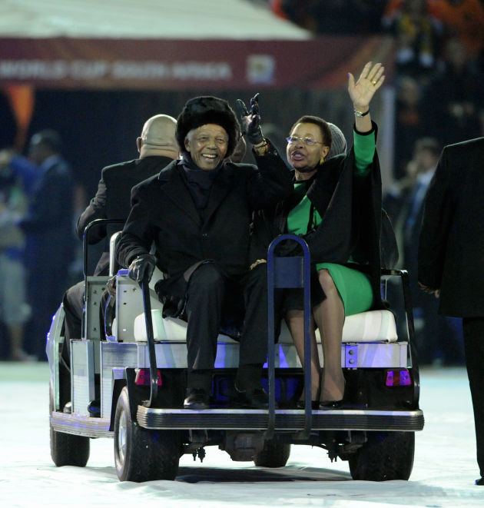43 of 45Nelson Mandela Photo Gallery: Nelson Mandela and his wife Gracia Machel tour the stadium before the start of the 2010 FIFA World Cup Final between the Netherlands and Spain on July 11, 2010, in Johannesburg, South Africa. (Photo by Bob Thomas) (Photo: Bob Thomas/Getty Images)

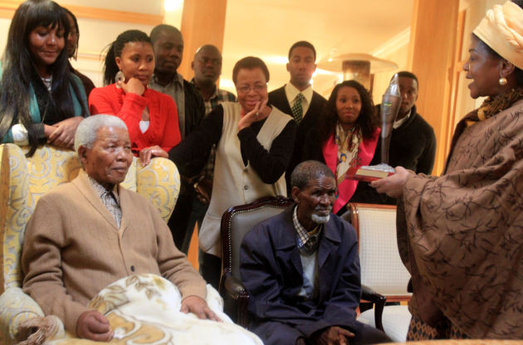44 of 45Nelson Mandela Photo Gallery: Mandela receives the African Nation Congress' centenary torch from their chairwoman Baleka Mbete at his home on May 30, 2012, in Qunu, South Africa. The original torch was lit during the party's 100th birthday celebrations earlier in the year, before a replica was presented to Mandela at his home. (Photo by Daily Dispatch/Gallo Images) (Photo: Getty Images)

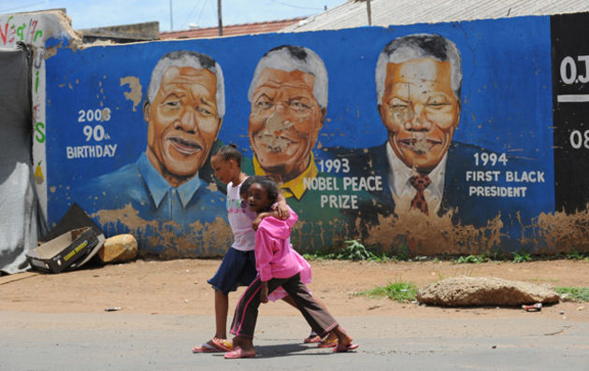45 of 45Nelson Mandela Photo Gallery: Generations of citizens in South Africa, both old and new, pay tribute to Nelson Mandela and all that he has done in the fight for the troubled country. Children walk past a mural of the leader for peace, which shows the different landmarks of his momentous life, on December 10, 2012, in Soweto, Gauteng, South Africa. (Photo by ALEXANDER JOE/AFP/Getty Images)

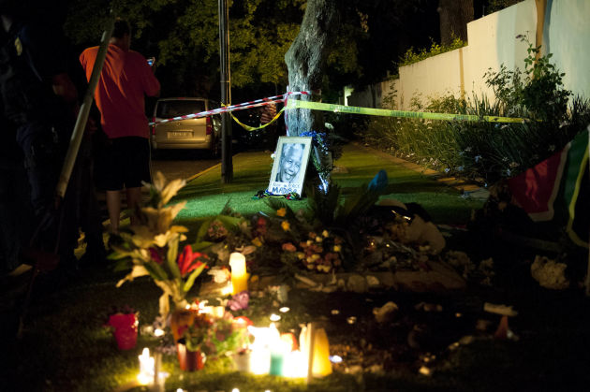1 of 45Remembering Nelson Mandela: Only hours after Nelson Mandela's death was announced on December 5, 2013, citizens of South Africa flocked to his home to pay tribute to the icon. (Photo by Delwyn Verasamy/Mail & Guardian/Gallo Images/Getty Images)

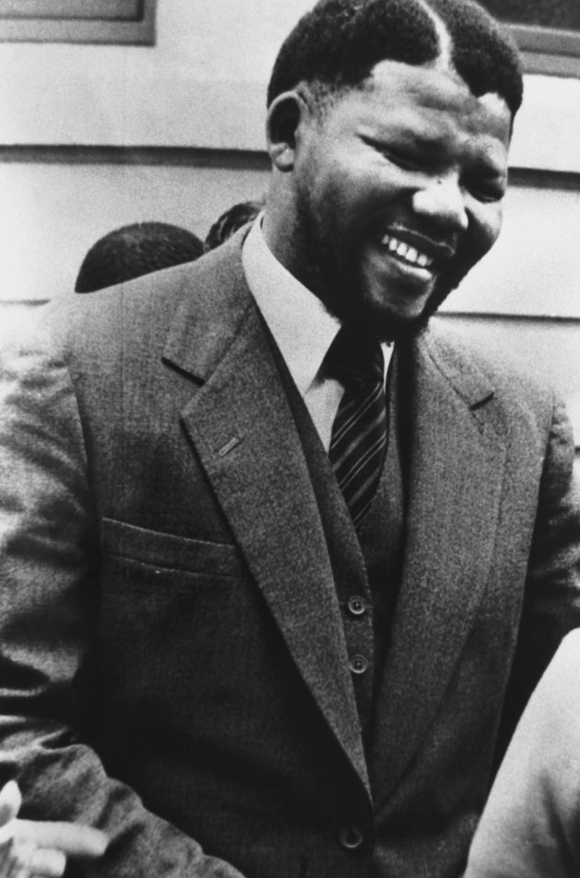2 of 45Nelson Mandela Photo Gallery: Nelson Mandela was the leader of the African National Congress in the 1960s before he was later sentenced to life in prison for sabotage. (Photo courtesy of Getty Images)

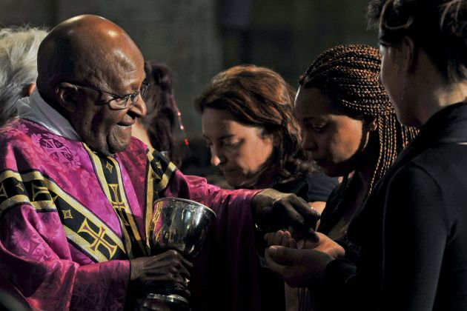3 of 45Remembering Nelson Mandela: Archbishop Desmond Tutu led a prayer for Nelson Mandela at St. George's cathedral on December 6, 2013, in Cape Town, South Africa. (Photo by Jaco Marais/Foto24/Gallo Images/Getty Images)

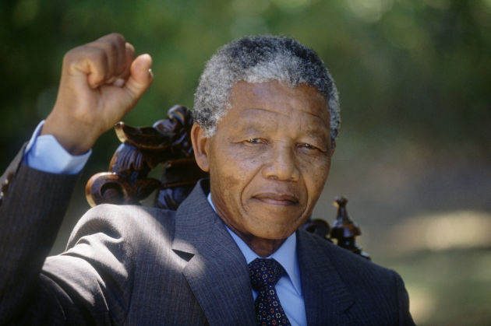4 of 45Nelson Mandela Photo Gallery: Nelson Mandela holds up his clenched fist in triumph the day after his release from prison in 1990 after 27 years at the age of 72. (Photo courtesy of Getty Images)



**Early Life**

Nelson Mandela was born Rolihlahla Mandela on July 18, 1918, in the tiny village of Mvezo, on the banks of the Mbashe River in Transkei, South Africa. "Rolihlahla" in the Xhosa language literally means "pulling the branch of a tree," but more commonly translates as "troublemaker."

Nelson Mandela's father, who was destined to be a chief, served as a counselor to tribal chiefs for several years, but lost both his title and fortune over a dispute with the local colonial magistrate. Mandela was only an infant at the time, and his father's loss of status forced his mother to move the family to Qunu, an even smaller village north of Mvezo. The village was nestled in a narrow grassy valley; there were no roads, only foot paths that linked the pastures where livestock grazed. The family lived in huts and ate a local harvest of maize, sorghum, pumpkin and beans, which was all they could afford. Water came from springs and streams and cooking was done outdoors. Mandela played the games of young boys, acting out male rights-of-passage scenarios with toys he made from the natural materials available, including tree branches and clay.

At the suggestion of one of his father's friends, Mandela was baptized in the Methodist Church. He went on to become the first in his family to attend school. As was custom at the time, and probably due to the bias of the British educational system in South Africa, Mandela's teacher told him that his new first name would be Nelson.

When Mandela was 9 years old, his father died of lung disease, causing his life to change dramatically. He was adopted by Chief Jongintaba Dalindyebo, the acting regent of the Thembu people—a gesture done as a favor to Mandela's father, who, years earlier, had recommended Jongintaba be made chief. Mandela subsequently left the carefree life he knew in Qunu, fearing that he would never see his village again. He traveled by motorcar to Mqhekezweni, the provincial capital of Thembuland, to the chief's royal residence. Though he had not forgotten his beloved village of Qunu, he quickly adapted to the new, more sophisticated surroundings of Mqhekezweni.

Mandela was given the same status and responsibilities as the regent's two other children, his son and oldest child, Justice, and daughter Nomafu. Mandela took classes in a one-room school next to the palace, studying English, Xhosa, history and geography. It was during this period that Mandela developed an interest in African history, from elder chiefs who came to the Great Palace on official business. He learned how the African people had lived in relative peace until the coming of the white people. According to the elders, the children of South Africa had previously lived as brothers, but white men had shattered this fellowship. While black men shared their land, air and water with whites, white men took all of these things for themselves.

When Mandela was 16, it was time for him to partake in the traditional African circumcision ritual to mark his entrance into manhood. The ceremony of circumcision was not just a surgical procedure, but an elaborate ritual in preparation for manhood. In African tradition, an uncircumcised man cannot inherit his father's wealth, marry or officiate at tribal rituals. Mandela participated in the ceremony with 25 other boys. He welcomed the opportunity to partake in his people's customs and felt ready to make the transition from boyhood to manhood. His mood shifted during the proceedings, however, when Chief Meligqili, the main speaker at the ceremony, spoke sadly of the young men, explaining that they were enslaved in their own country. Because their land was controlled by white men, they would never have the power to govern themselves, the chief said. He went on to lament that the promise of the young men would be squandered as they struggled to make a living and perform mindless chores for white men. Mandela would later say that while the chief's words didn't make total sense to him at the time, they would eventually formulate his resolve for an independent South Africa.

From the time Mandela came under the guardianship of Regent Jongintaba, he was groomed to assume high office, not as a chief, but a counselor to one. As Thembu royalty, Mandela attended a Wesleyan mission school, the Clarkebury Boarding Institute and Wesleyan College, where, he would later state, he achieved academic success through "plain hard work." He also excelled at track and boxing. Mandela was initially mocked as a "country boy" by his Wesleyan classmates, but eventually became friends with several students, including Mathona, his first female friend.

In 1939, Mandela enrolled at the University College of Fort Hare, the only residential center of higher learning for blacks in South Africa at the time. Fort Hare was considered Africa's equivalent of the University of Oxford or Harvard University, drawing scholars from all parts of sub-Sahara Africa. In his first year at the university, Mandela took the required courses, but focused on Roman Dutch law to prepare for a career in civil service as an interpreter or clerk—regarded as the best profession that a black man could obtain at the time.

In his second year at Fort Hare, Mandela was elected to the Student Representative Council. For some time, students had been dissatisfied with the food and lack of power held by the SRC. During this election, a majority of students voted to boycott unless their demands were met. Aligning with the student majority, Mandela resigned from his position. Seeing this as an act of insubordination, the university's Dr. Kerr expelled Mandela for the rest of the year and gave him an ultimatum: He could return to the school if he agreed to serve on the SRC. When Mandela returned home, the regent was furious, telling him unequivocally that he would have to recant his decision and go back to school in the fall.

**Mandela's Imprisonment**

A few weeks after Mandela returned home, Regent Jongintaba announced that he had arranged a marriage for his adopted son. The regent wanted to make sure that Mandela's life was properly planned, and the arrangement was within his right, as tribal custom dictated. Shocked by the news, feeling trapped and believing that he had no other option than to follow this recent order, Mandela ran away from home. He settled in Johannesburg, where he worked a variety of jobs, including as a guard and a clerk, while completing his bachelor's degree via correspondence courses. He then enrolled at the University of Witwatersrand in Johannesburg to study law.

Mandela soon became actively involved in the anti-apartheid movement, joining the African National Congress in 1942. Within the ANC, a small group of young Africans banded together, calling themselves the African National Congress Youth League. Their goal was to transform the ANC into a mass grassroots movement, deriving strength from millions of rural peasants and working people who had no voice under the current regime. Specifically, the group believed that the ANC's old tactics of polite petitioning were ineffective. In 1949, the ANC officially adopted the Youth League's methods of boycott, strike, civil disobedience and non-cooperation, with policy goals of full citizenship, redistribution of land, trade union rights, and free and compulsory education for all children.

For 20 years, Mandela directed peaceful, nonviolent acts of defiance against the South African government and its racist policies, including the 1952 Defiance Campaign and the 1955 Congress of the People. He founded the law firm Mandela and Tambo, partnering with Oliver Tambo, a brilliant student he'd met while attending Fort Hare. The law firm provided free and low-cost legal counsel to unrepresented blacks.

In 1956, Mandela and 150 others were arrested and charged with treason for their political advocacy (they were eventually acquitted). Meanwhile, the ANC was being challenged by Africanists, a new breed of [black activists](http://www.biography.com/people/groups/activists/african-american) who believed that the pacifist method of the ANC was ineffective. Africanists soon broke away to form the Pan-Africanist Congress, which negatively affected the ANC; by 1959, the movement had lost much of its militant support.

In 1961, Mandela, who was formerly committed to nonviolent protest, began to believe that armed struggle was the only way to achieve change. He subsequently co-founded Umkhonto we Sizwe, also known as MK, an armed offshoot of the ANC dedicated to sabotage and guerilla war tactics to end apartheid. In 1961, Mandela orchestrated a three-day national workers' strike. He was arrested for leading the strike the following year, and was sentenced to five years in prison. In 1963, Mandela was brought to trial again. This time, he and 10 other ANC leaders were sentenced to life imprisonment for political offenses, including sabotage.

Nelson Mandela was incarcerated on Robben Island for 18 of his 27 years in prison. During this time, he contracted tuberculosis and, as a black political prisoner, received the lowest level of treatment from prison workers. However, while incarcerated, Mandela was able to earn a Bachelor of Law degree through a University of London correspondence program.

A 1981 memoir by South African intelligence agent Gordon Winter described a plot by the South African government to arrange for Mandela's escape so as to shoot him during the recapture; the plot was foiled by British intelligence. Mandela continued to be such a potent symbol of black resistance that a coordinated international campaign for his release was launched, and this international groundswell of support exemplified the power and esteem that Mandela had in the global political community.

In 1982, Mandela and other ANC leaders were moved to Pollsmoor Prison, allegedly to enable contact between them and the South African government. In 1985, President P.W. Botha offered Mandela's release in exchange for renouncing armed struggle; the prisoner flatly rejected the offer. With increasing local and international pressure for his release, the government participated in several talks with Mandela over the ensuing years, but no deal was made. It wasn't until Botha suffered a stroke and was replaced by Frederik Willem de Klerk that Mandela's release was finally announced—on February 11, 1990. De Klerk also unbanned the ANC, removed restrictions on political groups and suspended executions.

**Prison Release and Presidency**

Upon his release from prison, Nelson Mandela immediately urged foreign powers not to reduce their pressure on the South African government for constitutional reform. While he stated that he was committed to working toward peace, he declared that the ANC's armed struggle would continue until the black majority received the right to vote.

In 1991, Mandela was elected president of the African National Congress, with lifelong friend and colleague Oliver Tambo serving as national chairperson. Mandela continued to negotiate with President F.W. de Klerk toward the country's first multiracial elections. White South Africans were willing to share power, but many black South Africans wanted a complete transfer of power. The negotiations were often strained and news of violent eruptions, including the assassination of ANC leader Chris Hani, continued throughout the country. Mandela had to keep a delicate balance of political pressure and intense negotiations amid the demonstrations and armed resistance.

In 1993, Mandela and President de Klerk were jointly awarded the Nobel Peace Prize for their work toward dismantling apartheid. And due in no small part to their work, negotiations between black and white South Africans prevailed: On April 27, 1994, South Africa held its first democratic elections. Nelson Mandela was inaugurated as the country's first black president on May 10, 1994, at the age of 77, with de Klerk as his first deputy.

Also in 1994, Mandela published an autobiography, *Long Walk to Freedom*, much of which he had secretly written while in prison. The following year, he was awarded the Order of Merit.

From 1994 until June 1999, Mandela worked to bring about the transition from minority rule and apartheid to black majority rule. He used the nation's enthusiasm for sports as a pivot point to promote reconciliation between whites and blacks, encouraging black South Africans to support the once-hated national rugby team. In 1995, South Africa came to the world stage by hosting the Rugby World Cup, which brought further recognition and prestige to the young republic.

Mandela also worked to protect South Africa's economy from collapse during his presidency. Through his Reconstruction and Development Plan, the South African government funded the creation of jobs, housing and basic health care. In 1996, Mandela signed into law a new constitution for the nation, establishing a strong central government based on majority rule, and guaranteeing both the rights of minorities and the freedom of expression.

**Retirement and Later Career**

By the 1999 general election, Nelson Mandela had retired from active politics. He continued to maintain a busy schedule, however, raising money to build schools and clinics in South Africa's rural heartland through [his foundation](http://www.nelsonmandela.org/p90/index.html), and serving as a mediator in Burundi's civil war. He also published a number of books on his life and struggles, among them *No Easy Walk to Freedom*; *Nelson Mandela: The Struggle is my Life*; and *Nelson Mandela's Favorite African Folktales*.

Mandela was diagnosed and treated for prostate cancer in 2001. In June 2004, at the age of 85, he announced his formal retirement from public life and returned to his native village of Qunu.

On July 18, 2007, Mandela convened a group of world leaders, including Graca Machel (whom Mandela would wed in 1998), Desmond Tutu, Kofi Annan, Ela Bhatt, Gro Harlem Brundtland, Jimmy Carter, Li Zhaoxing, Mary Robinson and Muhammad Yunus, to address some of the world's toughest issues. Aiming to work both publicly and privately to find solutions to problems around the globe, the group was aptly named "The Elders." The Elders' impact has spanned Asia, the Middle East and Africa, and their actions have included promoting peace and women's equality, demanding an end to atrocities, and supporting initiatives to address humanitarian crises and promote democracy.

In addition to advocating for peace and equality on both a national and global scale, in his later years, Mandela remained committed to the fight against AIDS—a disease that killed Mandela's son, Makgatho, in 2005.

**In Recent Years**

Nelson Mandela made his last public appearance at the final match of the World Cup in South Africa in 2010. He remained largely out of the spotlight in his later years, choosing to spend much of his time in his childhood community of Qunu, south of Johannesburg. He did, however, visit with U.S. first lady Michelle Obama, wife of President Barack Obama, during her trip to South Africa in 2011.

After suffering a lung infection in January 2011, Mandela was briefly hospitalized in Johannesburg to undergo surgery for a stomach ailment in early 2012. He was released after a few days, later returning to Qunu. Mandela would be hospitalized many times over the next several years—in December 2012, March 2013 and June 2013—for further testing and medical treatment relating to his recurrent lung infection. Following his June 2013 hospital visit, Mandela's wife, Graca Machel, canceled a scheduled appearance in London to remain at her husband's his side, and his daughter, Zenani Dlamini, Argentina's South African ambassador, flew back to South Africa to be with her father. Jacob Zuma, South Africa's president, issued a statement in response to public concern over Mandela's March 2013 health scare, asking for support in the form of prayer: "We appeal to the people of South Africa and the world to pray for our beloved Madiba and his family and to keep them in their thoughts," Zuma said.

**Death and Legacy**

On December 5, 2013, at the age of 95, Nelson Mandela died at his home in Johannesburg, South Africa. Zuma released a statement later that day, in which he spoke to Mandela's legacy: "Wherever we are in the country, wherever we are in the world, let us reaffirm his vision of a society ... in which none is exploited, oppressed or dispossessed by another," he said. For decades to come, Nelson Mandela will continue to be a source of inspiration for [civil rights activists](http://www.biography.com/people/groups/activists/civil-rights-activists) worldwide.

In 2009, [Mandela's birthday](http://www.biography.com/bio-now/nelson-mandelas-birthday-and-biography-a-timeline-of-events-20881773) (July 18) was declared Mandela Day, an international day to promote global peace and celebrate the South African leader's legacy. According to the [Nelson Mandela Centre of Memory](http://www.nelsonmandela.org/), the annual event is meant to encourage citizens worldwide to give back the way that Mandela has throughout his lifetime. A statement on the Nelson Mandela Centre of Memory's website reads: "Mr. Mandela gave 67 years of his life fighting for the rights of humanity. All we are asking is that everyone gives 67 minutes of their time, whether it's supporting your chosen charity or serving your local community."

**Personal Life**

Mandela was married three times, beginning with Evelyn Ntoko Mase (m. 1944-1957). The couple had four children together: Madiba Thembekile, Makgatho (d. 2005), Makaziwe and Maki. Mandela wed [Winnie Madikizela](http://www.biography.com/people/winnie-mandela-9397037) in 1958; the couple had two daughters together, Zenani and Zindziswa, before splitting in 1996. Two years later, Mandela married Graca Machel, with whom he remained until his death in 2013.

Sources:

<http://en.wikipedia.org/wiki/Nelson_Mandela>

<http://www.biography.com/people/nelson-mandela-9397017#early-life&awesm=~oEdAXBppMQu47x>